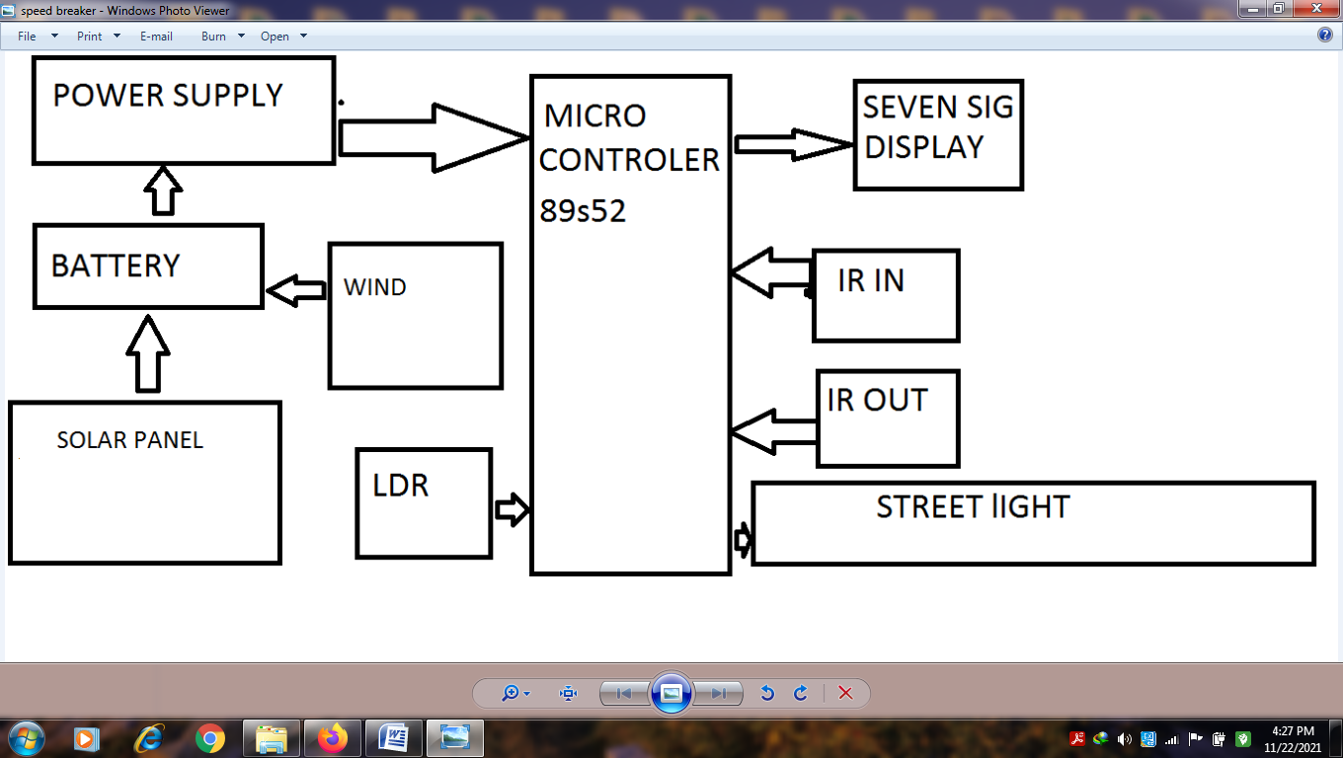

**Hardware Specifications**

* 8051 series microcontroller
* LEDs
* Transformer
* IR LEDs
* Diodes
* Light Sensor
* Transistors
* Voltage Regulator
* Photodiodes
* Solar
* Wind
* Battery
* Display
* Ir led
* cristal

**Software Specifications**

* Keil µVision IDE
* MC Programming Language: Embedded C

The project aims at saving energy by detecting the vehicle movement on highways and switching on the block of street light ahead of it and simultaneously switching off the trailing lights. The project requires sensors to detect the vehicle movements and switches on the lights ahead of it. As soon as the vehicle moves ahead the trailing lights automatically switches off. This can be used to save a lot of energy instead of using conventional system where the street lights are remained ON.

This proposed system provides a solution for energy saving. This is achieved by sensing an approaching vehicle and then switches ON a block of street lights ahead of the vehicle. As the vehicle passes by, the trailing lights switch OFF automatically. Thus, we save a lot of energy. So when there are no vehicles on the highway, t

Sensors used on either side of the road senses vehicle movement and sends logic commands to microcontroller to switch ON/OFF the LEDs. Thus this way of dynamically changing intensity ON/OFF helps in saving a lot of energy. The sensors sense the vehicle movements and send it to a 8051 family microcontroller that initiates commands for switching the lights ON/OFF